How to connect to the cluster

You can only connect to the cluster from within the LUH network. If you want to connect from the “outside” (e.g. from Home), you'll have to establish a VPN connection to the university’s network first. See VPN Service for details.
Please note: Working from outside the LUH may feel much slower than from your office, depending on the quality (bandwidth, latency, symmetry of up- and downstream) of your internet connection. If graphical applications feel sluggish, it is usually due to the connection and/or the network components in between, not a technical problem with the cluster system. You should also keep in mind the necessary bandwidth for a graphical connection on a high-resolution screen. Quite frequently, you can drastically improve performance by experimenting with the compression settings of X2Go, reducing window sizes, or the use of Open OnDemand as described below in this guide. If you have a good internet connection, you should be able to work quite comfortably from Home, except perhaps if you are in countries that are distant to Germany.
We support the following methods for connecting to the compute cluster:
- SSH - secure shell client
- X2Go - remote desktop sessions
- Web browser - Open OnDemand web portal
The following addresses should be used to connect to the cluster system:
- login.cluster.uni-hannover.de in order to develop, prepare and submit jobs, editing text files.
- transfer.cluster.uni-hannover.de whenever you want to transfer data to/from the cluster.
☛IMPORTANT☚: The login machines are not to be used for computations. In order to keep these nodes accessible for everyone, processes that use too much cpu time will get killed automatically after 30 minutes of elapsed cpu-time (that translates to only a few minutes if you try to start a parallel job there. Don't do that). We will also kill anything that uses more “elaborate” mechanisms trying to circumvent the limits, and we will disable accounts that we determine to be acting in bad faith. Please use interactive jobs for tasks like pre- or post-processing and even some larger compilations in order to avoid the frustrating experience of sudden shut down of your application. You can, of course, also use our Open OnDemand web portal which is reachable under https://login.cluster.uni-hannover.de if you get overwhelmed with all the options of the batch system at first.
Please note: File transfers on the login nodes will also get aborted if the execution time limit is reached. On the transfer node, execution time is unlimited, but you can not submit batch jobs from there to avoid clogging the node. We recommend to use ssh/scp or rsync to transfer files to/from the cluster, in particular for large files. The rsync command is particularly useful if your connection is unstable, because it can continue transfers that have been aborted.

If you already know what you are doing: current hashes of the host key fingerprints of login and transfer nodes
Connecting via ssh for the first time, you will probably get asked about the authenticity of the host key/hash presented to you by the login node you are trying to connect. This is done in order to ensure that you really connect to our servers and not a machine that someone could in theory have inserted as a so-called “man-in-the-middle-attack” in your connection or with another of various methods. So we suggest to check what the dialogue presents to you to ensure you do not enter your password at the wrong site. You will probably see only one of the following lines, since there are various algorithms used to compute the fingerprints and we do not know which one your tool will use - check for the algorithm used at the end of the line, e.g. ECDSA, ED25519.
The correct host key fingerprints are
MD5: bf:aa:71:bd:d1:19:d4:4f:b5:60:e7:cb:c4:26:85:a7 (ECDSA)
SHA256: cYIZZQC96J5bhannZnH2cGQLIBPLQVy29HNc6/vnyFg (ECDSA)
SHA1: fb:a1:47:ad:97:99:b3:66:86:06:8d:9d:56:46:61:3a:44:9c:a6:cb (ECDSA)
MD5: 3b:0a:17:0f:53:85:40:87:c2:be:ed:65:fb:40:59:8a (ED25519)
SHA256: sG8ZYabQctyGjxPD7X8K2IBxJIE5xHHZ9mQqjlVcjxo (ED25519)
SHA1: 51:f7:b9:0a:e3:84:8e:d8:2c:a4:e7:7d:42:14:d3:8b:62:2e:a6:5d (ED25519)
MD5: bd:b2:04:f9:4e:36:c1:b6:36:8e:d9:03:cc:5d:75:c4 (RSA)
SHA256: zkVF8Xyxmm7bOEKTNOlvRKe+nG1oHZDeOtY3Un60grg (RSA)
SHA1: ed:e3:ed:e6:bf:4f:29:9a:2c:72:92:c1:b4:ff:a6:b9:81:f6:6b:45 RSA)
MD5: e3:c7:80:67:68:5b:d9:78:df:50:d7:e1:c5:ae:bf:e7 (DSA)
SHA256: DuWre1exwDsyTzD4yIMy6Oc2CFBCmx5o+l0LmWjMvUc (DSA)
SHA1: 85:95:f5:c9:9b:2b:29:82:5f:13:70:b9:2b:43:44:84:22:8f:87:40 (DSA)
If at least one of the fingerprints matches the one you get asked about, you can be reasonably sure that you are trying to connect to the cluster. In case you are using the command-line ssh client, it will remember an affirmative answer by adding a line with that fingerprint to your ~/.ssh/known_hosts file. So you'll probably get asked only once.

SSH Connection to the cluster
The most basic option to connect to the cluster system is via SSH. For this, an ssh client is required, which comes with most Linux distributions by default and also should be readily available under Mac OS (start a terminal, applications::utilities).
Under Windows, you'll need to install an SSH Client like e.g. PuTTY or much more feature-rich and user friendly MobaXTerm. You could also install a Unix-like environment like Cygwin to benefit from some Unix-like functionality under Windows, but be aware that for many use cases, there may be easier ways to get you started (see below).
When you've found a terminal, the following command will establish a connection to the cluster system.
ssh username@login.cluster.uni-hannover.de
Replace username with your cluster user name.
Please note: The settings dialogue of a tool like PuTTY itself is not a terminal, it's only a settings dialogue. So PuTTY only needs to know the hostname you want to connect to, it executes the ssh command automatically when connecting. It will first ask for your username, except if you entered username@ in front of the host name, which would also be ok. It is sufficient to enter “login.cluster.uni-hannover.de” into the “Host name” field, make sure to NOT add “ssh” in front of it.
If you want to use graphical programs on the cluster system, add the option -X, which enables X11 forwarding (see below). Depending on your system, you may need to use -Y instead of -X.
ssh -X username@login.cluster.uni-hannover.de
Please note: Again, tools like e.g. PuTTY have their own setup. To get X11 forwarding with these tools, use the corresponding button. In the PuTTY configuration settings, this would be Connection::SSH::X11::Enable X11 forwarding.

Remote Desktop Sessions via X2Go
One way to enable the usage of graphical programs on the cluster is to run an X-Server on your local machine, which means nothing more than running a piece of software that other software (called X-Clients in this context, but really just the graphic programs that you start) can make graphic requests to. Conveniently, an X-Server is usually the foundation for graphic environments under Linux so it is usually already installed here, and graphical connections tunneled through ssh (via ssh -X or ssh -Y, see above) should work right out of the box, but Mac OS users will typically need to install an external package such as XQuartz. Under Windows, MobaXterm comes with an X-Server, while for PuTTY there is VcXsrv.
For improved performance, however, it may still be useful to install and configure the X2Go client, as connections made via X2Go are compressed and optimized. The standard “X” protocol is not designed for use over wide-area networks, and newer tools can improve performance quite a bit. Th X2Go client is part of most Linux distributions' package repositories.
On Windows, X2Go-client version 4.1.2.0 has been tested to work with the cluster.
X2Go can be obtained here. During installation, please make sure to check the “full installation” box to install all fonts. Otherwise, you may experience strange error messages later on.
Please configure the X2Go client as described in X2Go client configuration.
IMPORTANT: Never delete the ~/.x2go directory inside your cluster home folder, as it contains configuration data. Removing this directory on the cluster will corrupt your X2Go environment and completely block all your future X2Go connections to the cluster.

X2Go client configuration
Please note: We recommend using X2Go in broker mode to avoid having multiple desktop sessions. See section about X2Go Broker.
After starting the X2Go client, either using a desktop short-cut or using the start menu, a configuration dialogue is displayed. In this dialogue you should specify a session name and make the following four entries.
- Host: login.cluster.uni-hannover.de
- Login: Your user name
- SSH-Port: 22
- Session type: XFCE
The completed configuration dialogue is depicted in . Entries in the red boxes have to be set accordingly. Afterwards leave the configuration assistant by clicking the OK button.
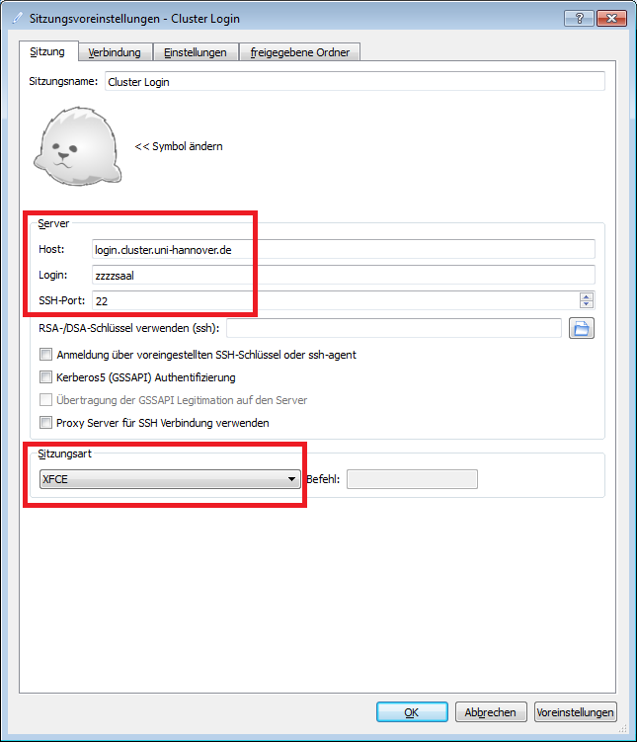X2Go configuration dialogue, entries in red boxes have to be se
On the right side of the main window the newly created session name is displayed, see figure . You can start this session by clicking on the session name (in the upper right corner in figure ) or by entering the session name in the dialogue box named session.
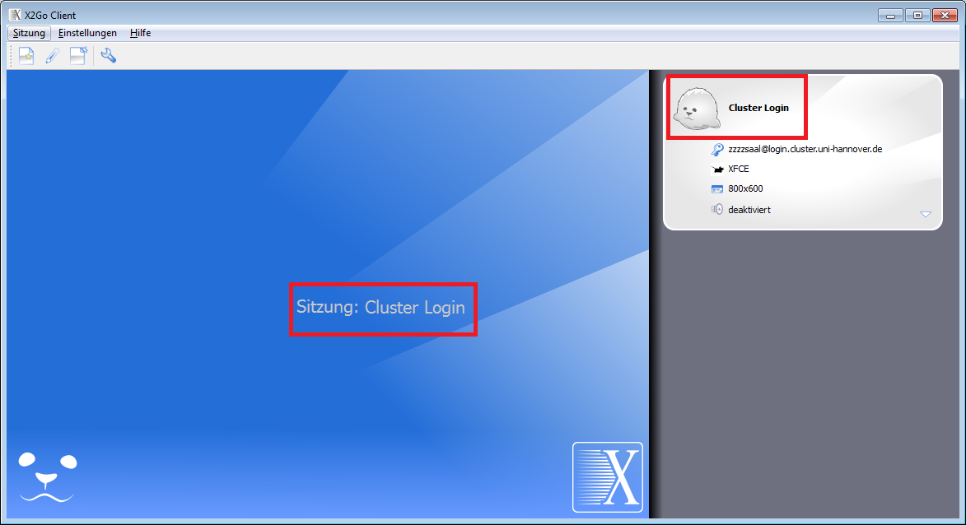 Start a new session by clicking or entering the session name.
The first time a connection is established, the login nodes’ host-key is unknown. A notification will pop up and you need to accept the host-key (see figure ) by pressing yes.
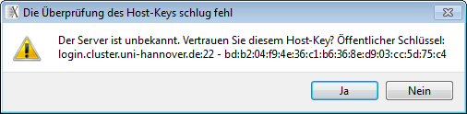 Host key verification dialogue
After a connection was successfully established an XFCE Desktop is displayed as depicted in figure .
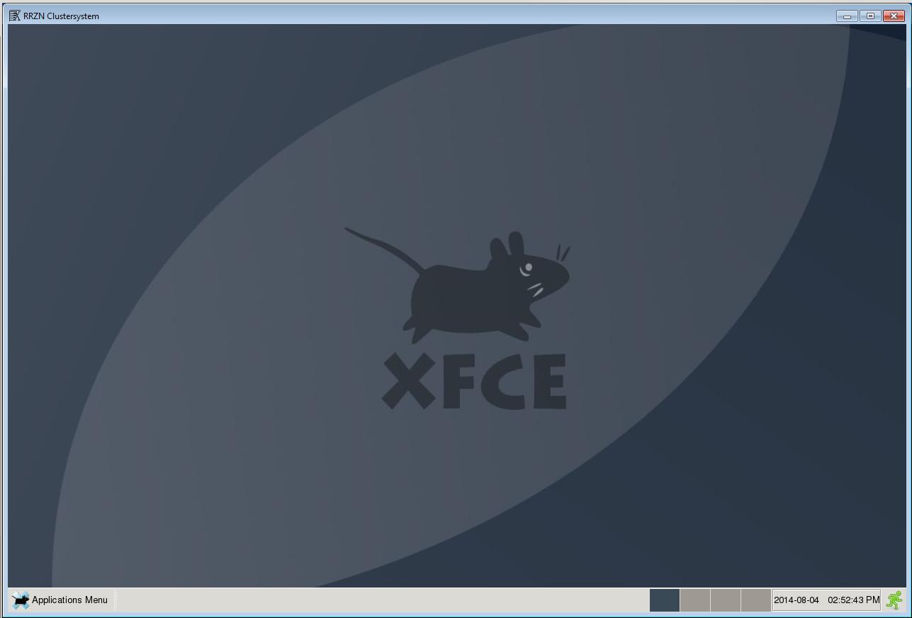 XFCE desktop with applications menu in the lower left corner
The Applications Menu in the bottom left corner can be used to start a console window and then load modules or submit jobs into the queue. You can open editors e.g. to write or edit batch scripts. Particularly interactive jobs which open graphical program windows can be run. To end your session either go to the Applications Menu or press the little green icon in the bottom right corner of your desktop.
When connecting to the cluster using login.cluster.uni-hannover.de you will be assigned to one of the login nodes used for the cluster to balance the connection load. Therefore, it may happen that by next connection you will be taken to a different login node rather than to a node you already have a running X2Go session. In order to avoid maintaining multiple simultaneously running sessions, which easily may lead to confusion, we recommend using X2Go client in broker mode, see the next section.
Note: Suspended X2Go sessions will be terminated after four weeks without prior notice.
Note: We had an issue that made it impossible to enter special characters using AltGr in a terminal within an X2Go session. We hope that this is now solved.

X2Go Broker
If you would like to reconnect to a graphical session, use X2Go broker. For example you could start a session at the university and reconnect to it at home. In order to do this, you have to establish a connection to the cluster via X2Go broker. After installing X2Go client, proceed as described below.

X2Go broker on Linux
Use the following command to establish a connection with X2Go broker (the following command should be on one line. Replace <username> with your cluster username).
x2goclient --broker-url=ssh://<username>@x2gobroker.cluster.uni-hannover.de/usr/bin/x2gobroker --broker-autologin

X2Go broker on Windows
Either edit the existing shortcut to X2Go or create a new one (chose “Eigenschaften” in Picture ).
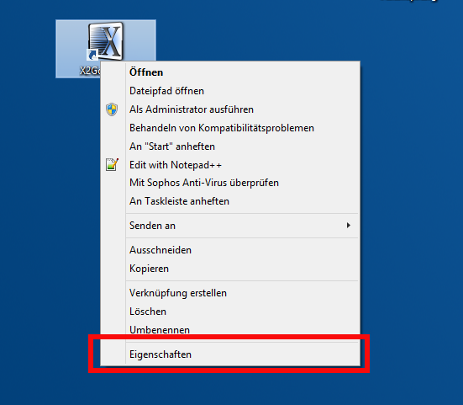 Edit X2Go shortcut
Extend the command given as “Ziel”, see Picture , with the following parameters (the following command should be on one line. Replace <username> with your cluster username).
"[...]x2goclient.exe" --broker-url=ssh://<username>@x2gobroker.cluster.uni-hannover.de/usr/bin/x2gobroker
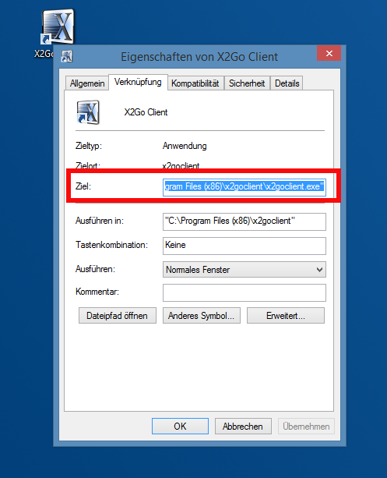 X2Go broker command
After providing your password, a session is listed in the X2Go window, see picture . Choose this session. You will get a desktop on the cluster system. You can reconnect to this session and continue working graphically.
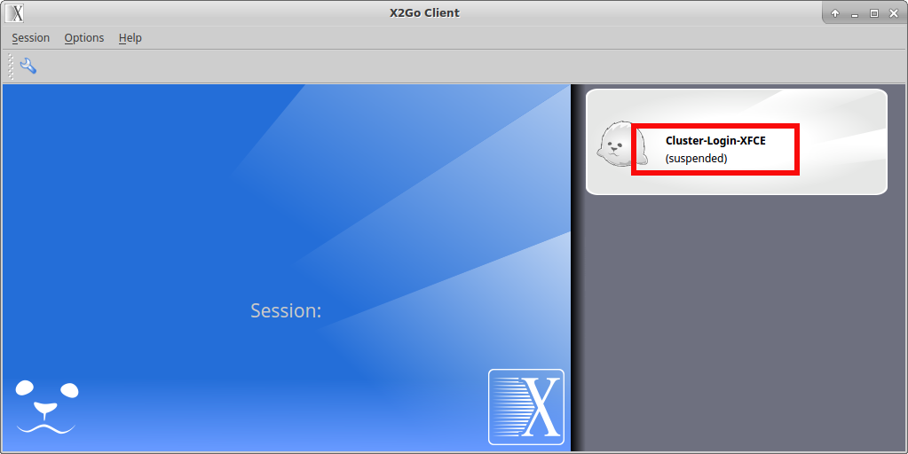 X2Go broker session
Please note: Suspended X2Go sessions will be terminated after four weeks without prior notice.

Cluster Web Portal
The web interface powered by the software package Open OnDemand allows you to access the LUIS cluster resources using a web browser without installing additional software on your personal workstation. The portal is currently confirmed to work with newer versions of Google Chrome (70+), Firefox (85+) and Microsoft Edge (90+). Any device connected to the university network and compatible with these browsers can be used. Safari is partially supported.
From within the Open OnDemand environment, you can:
- Create, submit, cancel and monitor batch jobs
- Open a terminal connection to cluster login servers and compute nodes
- Browse, edit, download and upload files in/to your HOME, BIGWORK and PROJECT directories
- Run noVNC Remote Desktop sessions on compute nodes for heavy GUI applications
- Run other preconfigured interactive applications like Jupyter/JupyterLab, MATLAB, COMSOL, etc
The Open OnDemand website provides additional information about the current and future directions of the project.

How to connect to the web portal
Please note: To access the portal, make sure you are connected to the University network, e.g. via the LUIS VPN Service.
Log on to the cluster web portal using your normal cluster login credentials by opening a new page in your web browser pointing to https://login.cluster.uni-hannover.de (see figure ).
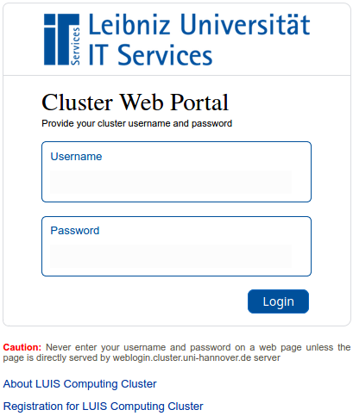 Cluster web portal login page
Once you have been connected to the portal, you will be presented with the main dashboard page, see figure . There, you will find several menus to enable access to the different Applications for File Browsing, Job Management and Interactive Computing. Tutorial videos in the section “Getting started with OnDemand” in the dashboard page (klick on “LUIS OnDemand Dashboard” on the top left of the web page) explain further details about using the web portal.
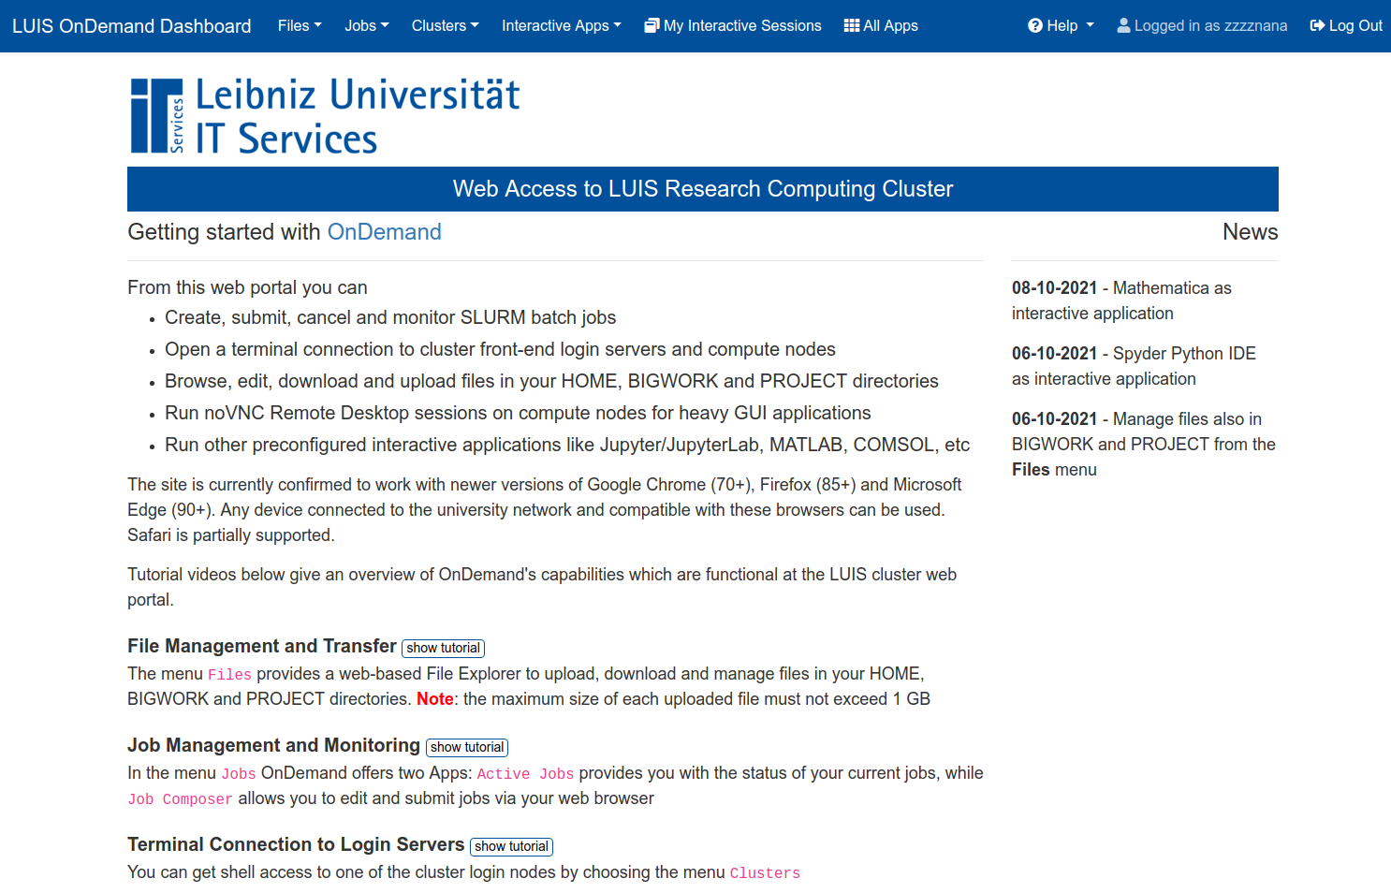 Cluster web portal dashboard page

Services available via Open OnDemand
- Remote visualization for interactive 3D work
- Jupyter on the cluster
- Code-Server on the cluster

